**(Array and object Question)**

Q.40 Write a JavaScript Program to display the current day and time in the following format. Sample Output: Today is Friday. Current Time is 12 PM: 12 : 22 2 ?

Ans :

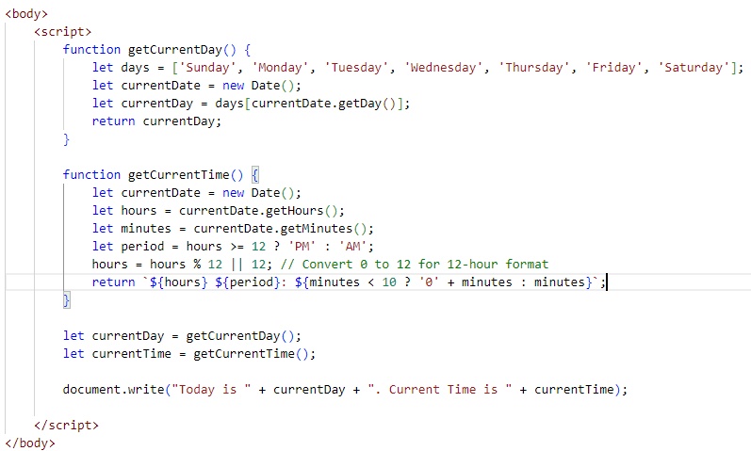

Output:

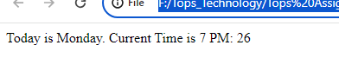

Q.41 Write a JavaScript program to get the current date?

Ans :

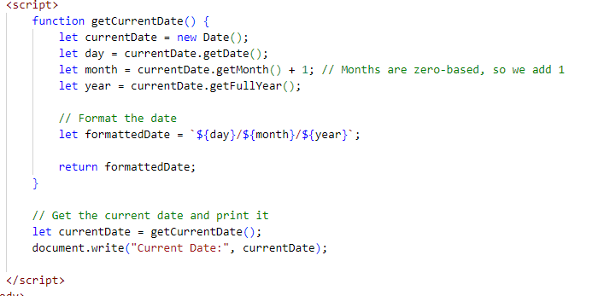

Output:

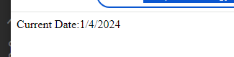

Q.42 Write a JavaScript program to compare two objects?

Ans :

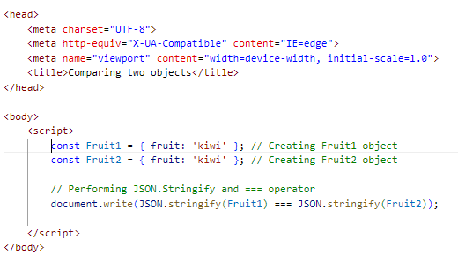

Output:



Q.43 Write a JavaScript program to convert an array of objects into CSV string?

Ans :

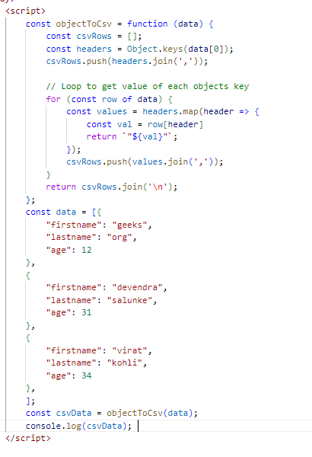

Output:

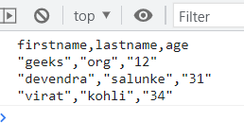

Q.44 Write a JavaScript program to capitalize first letter of a string?

Ans :

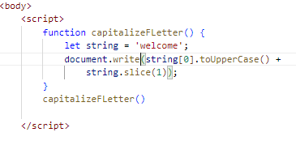

Output:



Q. 45 Write a JavaScript program to determine if a variable is array?

Ans :

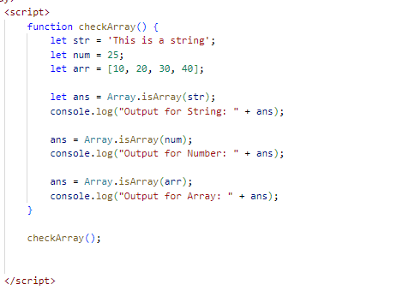

Output:

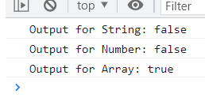

Q.46 Write a JavaScript program to clone an array?

Ans :

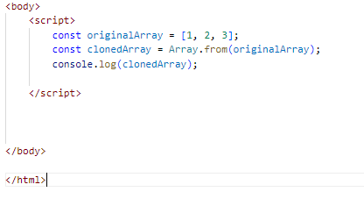



Q.47 What is the drawback of declaring methods directly in JavaScript objects?

Ans :

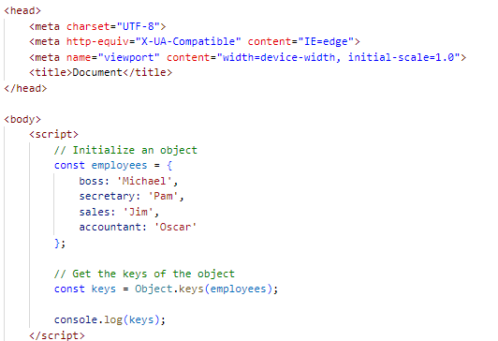

Output:



Q.48 Print the length of the string on the browser console using console.log()?

Ans :

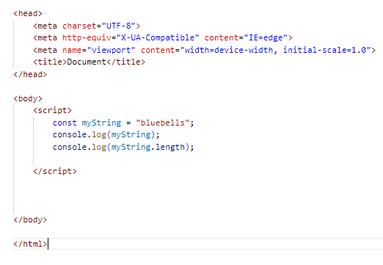

Output:

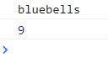

Q.49 Change all the string characters to capital letters using toUpperCase() method?

Ans :

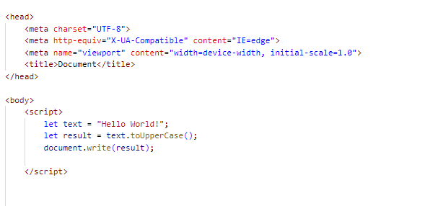

Output:



Q.50 What is the drawback of declaring methods directly in JavaScript objects?

Ans :

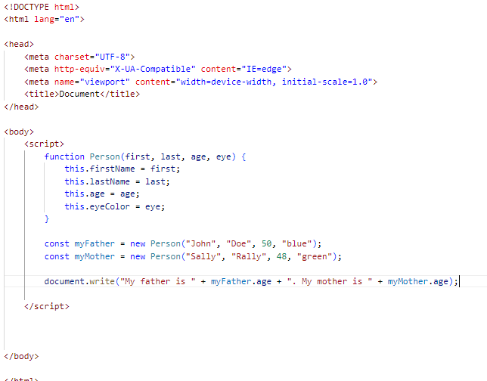

Output:



Q.51 Write a JavaScript program to get the current date.

Expected Output: mm-dd-yyyy, mm/dd/yyyy or dd-mm-yyyy, dd/mm/yyyy?

Ans :

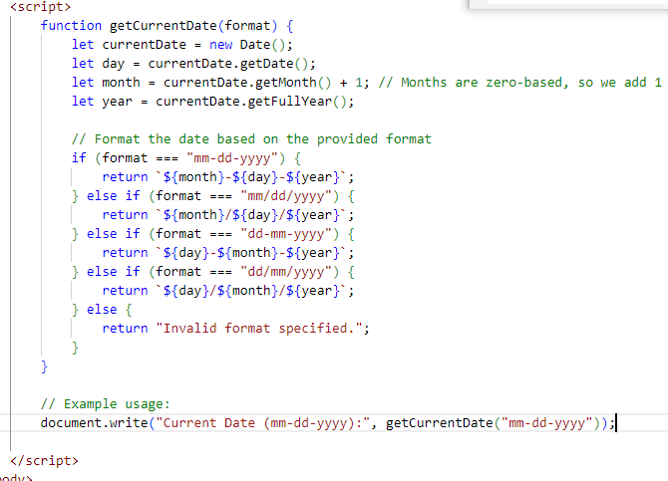

Output:

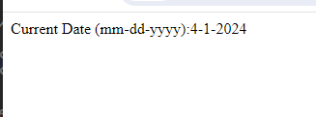

Q.52 Use indexOf to determine the position of the first occurrence of a in 30 Days Of JavaScript?

Ans :

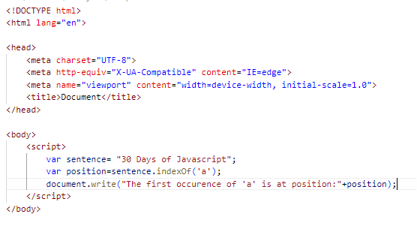

Output:



Q,53 Use lastIndexOf to determine the position of the last occurrence of a in 30 Days Of JavaScript?

Ans :

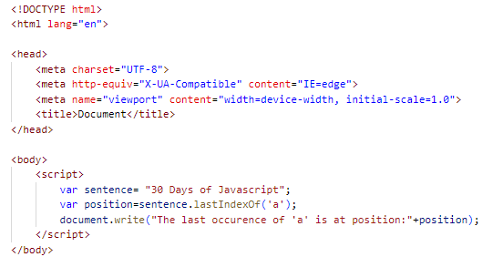

Output:



Q.54 Form Validtion in JS?

Ans :Form validation is the process of verifying that the data.

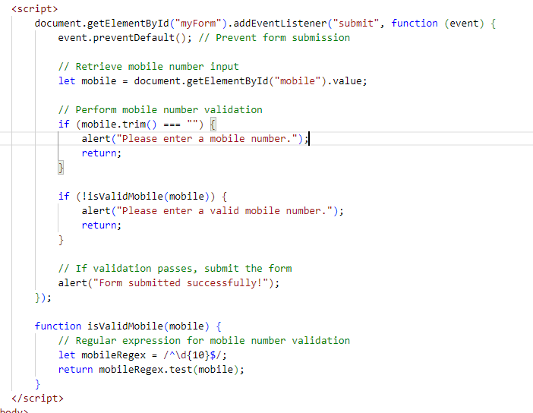

Output:

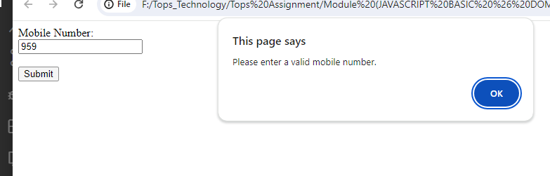

Q.55 Form in Email, number, Password, Validation?

Ans :

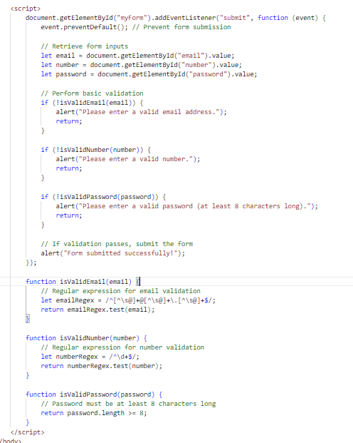

Output:

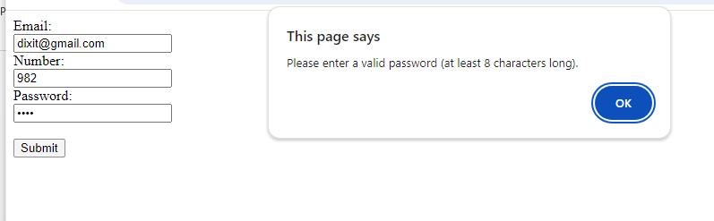

Q.56 Dynamic Form Validation in JS?

Ans:

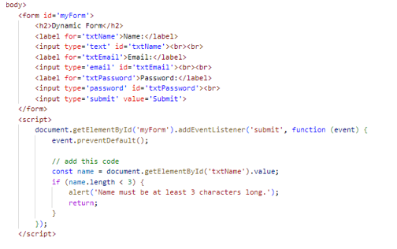

Output:

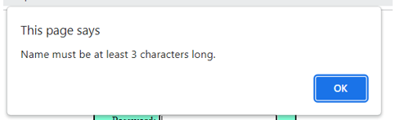

Q.57 how many type of JS Event? How to use it?

Ans : In JavaScript, there are many types of events that can occur, and these events can be categorized into various groups.

* Mouse Events: These events are triggered by mouse actions, such as clicking, hovering, dragging, etc. Examples include click, mouseover, mouseout, mousedown, mouseup, etc.
* Keyboard Events: These events are triggered by keyboard actions, such as pressing or releasing keys. Examples include keydown, keyup, keypress, etc.
* Form Events: These events are triggered by form-related actions, such as submitting a form, changing input values, etc. Examples include submit, change, input, focus, blur, etc.
* onclick Event Type : This is the most frequently used event type which occurs when a user clicks the left button of his mouse. You can put your validation, warning etc., against this event type.

Code :

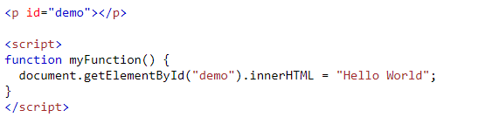

Output:

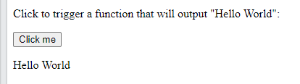

Q.59 What is Bom vs Dom in JS?

Ans :

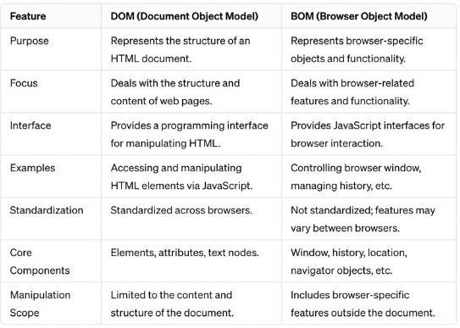

Q.60 Array vs object defences in JS?

Ans :

|  |  |
| --- | --- |
| Array | Object |
| Arrays are a special type of variable that is also mutable and can also be used to store a list of values. | Objects represent a special data type that is mutable and can be used to store a collection of data. |
| We use arrays whenever we want to create and store a list of multiple items in a single variable. | Objects are used to represent a “thing” in your code. That could be a person, a car, a building, a book, a character in a game — basically anything that is made up or can be defined by a set of characteristics. |
| Arrays use zero-based indexing, so the first item in an array has an index of 0, the second item an index of 1, and so on. | Properties in objects can be accessed, added, changed, and removed by using either **dot** or **bracket** notation. |

Q.61 Split the string into an array using split() Method?

Ans :

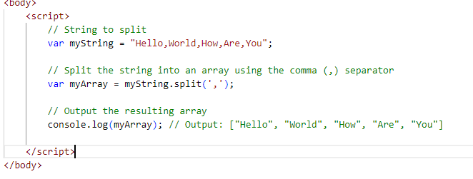

Output :

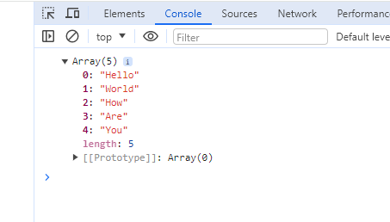

Q.62 Check if the string contains a word Script using includes() method?

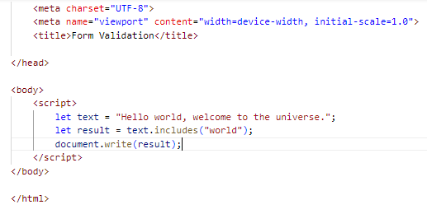

Output:



Q.63 Change all the string characters to lowercase letters using to Lowercase () Method.

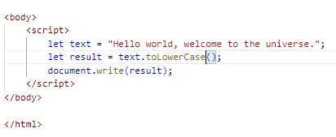

Output:



Q.64 What is Character at index 15 in ’30 Days of JavaScript’ string? Use char At () method.

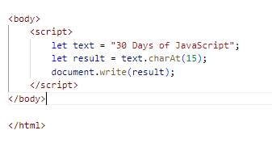

Output:



Q.65 copy to one string to another string in JS?

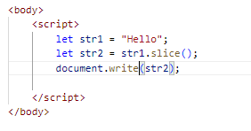

Output:



Q.66 Find the length of a string without using libraryFunction?

Ans :

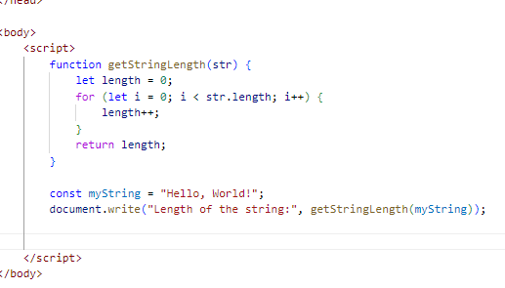

Output:



1). What is JavaScript ?

Ans.

* JavaScript is used to make webpages interactive.
* JavaScript can be used for client-side development as well as server-side developments.
* JavaScript is a lightweight, cross-platform, and interpreted scripting language.
* It is well-known for the development webpages, many non- browser environments also use it.
* JavaScript contains a standard library of object like array, date, and math and core  set of language element like operator control structure and statements.

2). What is the use of is NaN function ?

Ans.

* In JavaScript Nan is short for “No-a-Number”.
* The NaN() method returns true if a value is NaN.
* The NaN() method converts the value to a number before Testing it.

## 3). What is negative Infinity ?

## Ans.

* The negative infinity in JavaScript is a constant value which is used to represent a value which is the lowest available. This means that no other number is lesser than this value. It can be generated using a self-made function or by an arithmetic operation.

Note: JavaScript shows the NEGATIVE_INFINITY value as -Infinity.

Negative infinity is different from mathematical infinity in the following ways:

1. Negative infinity results in 0 when divided by any other number.
2. When divided by itself or positive infinity, negative infinity return NaN
3. Negative infinity, when divided by any positive number (apart from positive infinity) is negative infinity.
4. Negative infinity, divided by any negative number (apart from negative infinity) is positive infinity.
5. If we multiply negative infinity with NaN, we will get NaN as a result.
6. The product of NaN and negative infinity is 0.
7. The product of two negative infinities is always a positive infinity.
8. The product of both positive and negative infinity is always negative infinity.

Ex:-

<!DOCTYPE html>

<**html**>

<head>

<meta charset=”UTF-8”>

<meta Http-equiv=”X-UA-Compatible” content=”IE=edge”>

<meta name=”viewport” content=”width-device-width, initial-scale=1.0”>

<title>document</title>

</head>

<**body**>

    <**style**>

        h1 {

            color: green;

        }

    </**style**>

    <**h1**>Tops Technology</**h1**>

    <**h1**>

      What is negative infinity in JavaScript?

  </**h1**>

    <**button** onclick="TopsNegativeInfinity()">

      Generate negative infinite

  </**button**>

    <**p** id="Tops"></**p**>

    <**script**>

        function TopsNegativeInfinity() {

            //negative value greater than the

            //largest representable number in JavaScript

            var n = (-Number.MAX_VALUE) * 2;

            document.getElementById("Tops").innerHTML = n;

        }

    </**script**>

</**body**>

</**html**>

## 4). Which company developed JavaScript ?

## Ans.

## JavaScript is a scripting language developed by Netscape.

## It can be used to program web browser or even servers.

## It can dynamically update the contents of the webpage, which is the beauty of JavaScript.

## 5). What are undeclared and undefined variables ?

## Ans.

## Undeclared :-

## Undeclared variable means that the variables does not exist in the program at all.

## Ex:-

## Code:

## console.log(cat);

## Output:-

## ReferenceError: cat is not defined

## Undefined :-

## Undefined Variable has been declared but does not have value.

## Ex:-

## Code:

## var dog;

## console.log(dog);

## Output:-

## Undefined

6) Write the code for adding new elements dynamically?

Ans :

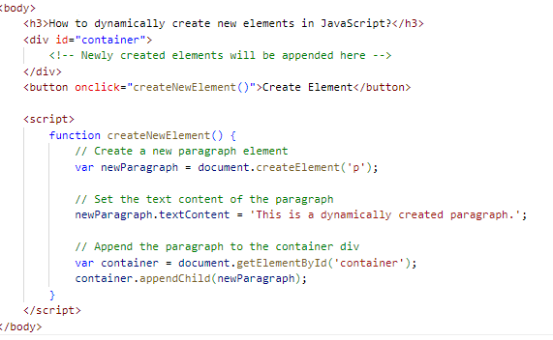

Output:

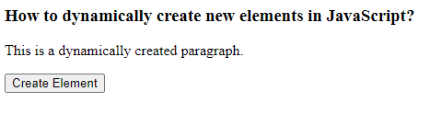

7) What is the difference between View State and Session State?

Ans:

| View State | Session State |
| --- | --- |
| Maintained at page level only. | Maintained at session level. |
| View state can only be visible from a single page and not multiple pages. | Session state value availability is across all pages available in a user session. |
| It will retain values in the event of a post back operation occurring. | In session state, user data remains in the server. Data is available to user until the browser is closed or there is session expiration. |
| Information is stored on the client’s end only. | Information is stored on the server. |

8) What is = = = operator?

Ans: The strict equality (= = =) operator checks whether its two operands are equal,

returning a Boolean result.

9) How can the style/class of an element be changed?

Ans :

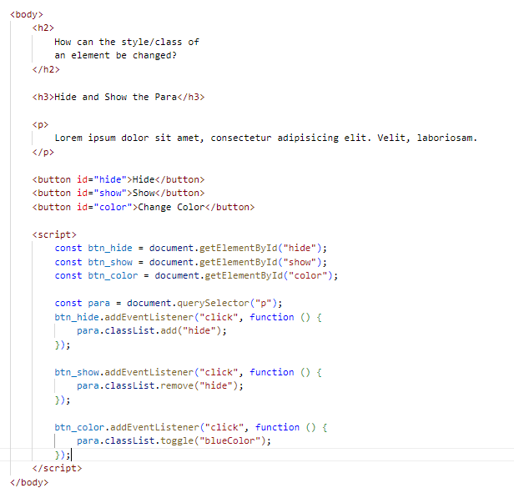

Output:

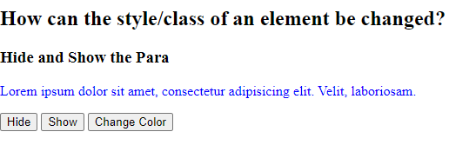

10) How to read and write a file using JavaScript?

## Ans:

## Write operation on a file: After the File System file is imported then, the writeFile () operation is called. The writeFile () method is used to write into the file in JavaScript.

## Reading from the file: After the File System module is imported, the reading of the file in JavaScript can be done by using the readFile () function.

11)What are all the looping structures in JavaScript?

Ans :

* for Loop: The for loop repeatedly executes a block of code until a specified condition evaluates to false.
* while Loop: The while loop executes a block of code as long as a specified condition is true.
* do...while Loop: The do...while loop is similar to the while loop, but it always executes the block of code at least once before checking the condition.
* for...in Loop: The for...in loop iterates over the enumerable properties of an object.
* for...of Loop: The for...of loop iterates over iterable objects (like arrays, strings, maps, sets, etc.), providing a concise syntax for iterating over their elements.

Q-12) How can you convert the string of any base to an integer in JavaScript?

Ans.)

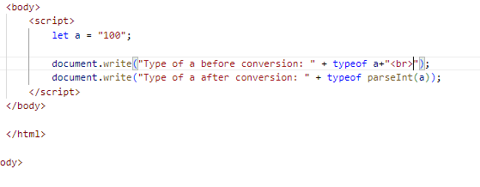

Output:



Q-13) What is the function of the delete operator?

Ans.)

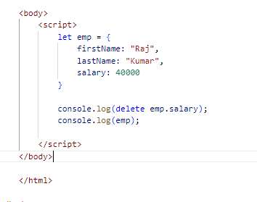

Output:

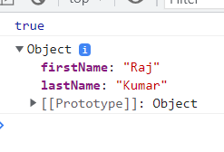

Q-14) What are all the types of Pop up boxes available in JavaScript?

Ans.) JavaScript has three kind of popup boxes: Alert box, Confirm box, and Prompt box.

* Alert Box:The ‘alert ()’function is used to display an alert dialog box with a specified message or ok button.

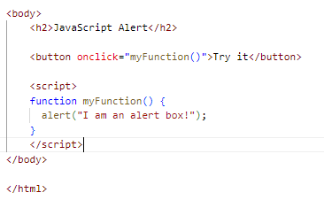

Output:

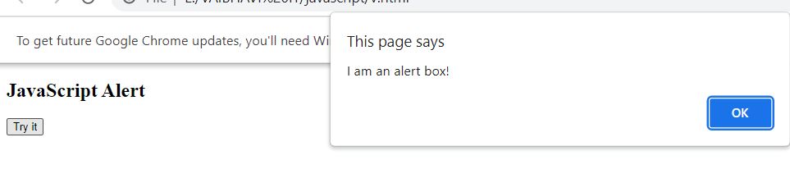

## Confirm Box: A confirm box is often used if you want the user to verify or accept something.

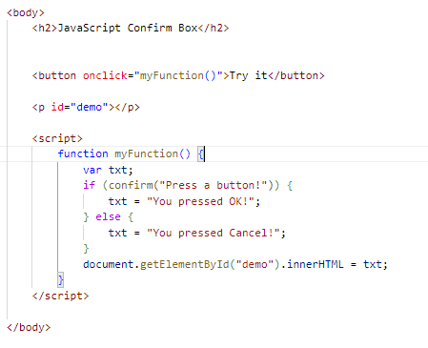

Output:

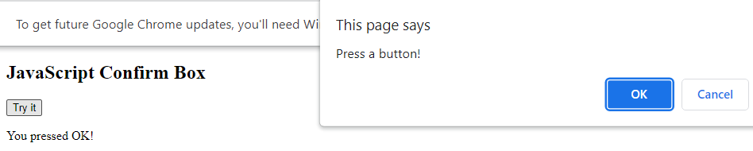

## Prompt Box: A prompt box is often used if you want the user to input a value before entering a page.

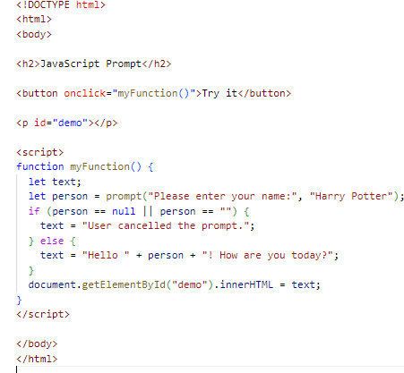

Output: 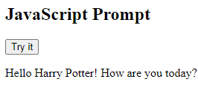

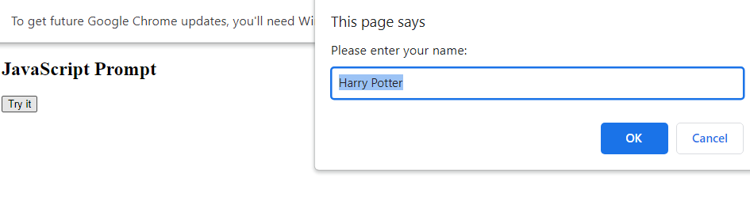

Q-14) What is the use of Void (0)?

Ans:

The void operator evaluates an expression and returns undefined. By running void (0) in the URL JavaScript code, nothing is evaluated or return.

Q-15) How can a page be forced to load another page in JavaScript?

Ans:

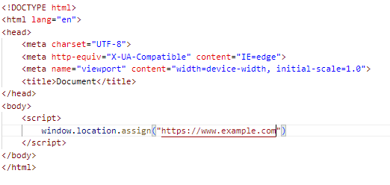

Q-16) What are the disadvantages of using innerHTML in JavaScript?

Ans:

* The use of innerHTML very slow: The process of using innerHTML is much slower as its contents as slowly built, also already parsed contents and elements are also re-parsed which takes time.
* Preserves event handlers attached to any DOM elements: The event handlers do not get attached to the new elements created by setting innerHTML automatically. To do so one has to keep track of the event handlers and attach it to new elements manually. This may cause a memory leak on some browsers.
* Content is replaced everywhere: Either you add, append, delete or modify contents on a webpage using innerHTML, all contents is replaced, also all the DOM nodes inside that element are reparsed and recreated.
* Appending to innerHTML is not supported: Usually, += is used for appending in JavaScript. But on appending to an Html tag using innerHTML, the whole tag is re-parsed